**Introduction:**

Our Dashboard is a robust tool crafted to offer users a seamless and insightful exploration of Airbnb data. With a user-friendly interface and powerful filters, you can delve into the intricacies of listings to make informed decisions.This user manual will guide you through the functionality of the dashboard, with a special focus on the five key filters that shape your analytical experience.

**Filter 1: Price Range**

Default Price Range: 0 to 500

The Price Range filter is your gateway to refining the data based on the cost of Airbnb listings. The default setting spans from 0 to 500, covering a wide spectrum of prices. To tailor your results, use the intuitive sliders to set a custom price range. This feature ensures that your analysis focuses on listings within your budget constraints, providing a personalized experience.

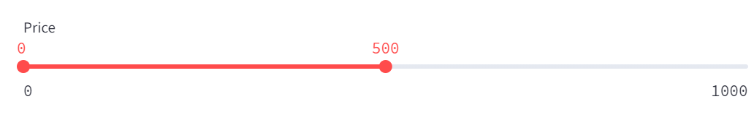

**Filter 2: Minimum Stays Range**

Default Minimum Stays Range: 1 to 100

The Minimum Stays Range filter empowers you to explore data based on the duration of guest stays. The default setting ranges from 1 to 100 nights. By adjusting the sliders, you can investigate listings that align with your desired stay duration. This filter is invaluable for users with specific accommodation preferences, ensuring that you find listings that cater to your preferred length of stay.

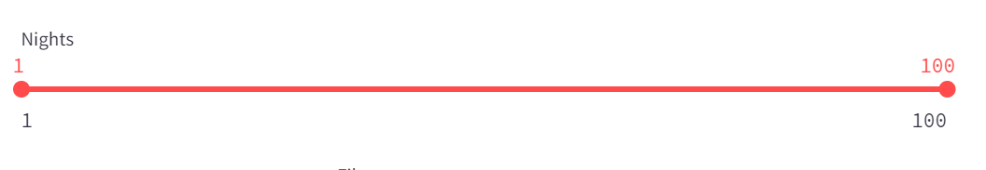

**Filter 3: Room Type**

Default: Any

The Room Type filter allows you to tailor your analysis based on the type of accommodation. Choose from "Entire Home," "Private Room," or "Shared Room" to focus on listings that align with your preferences. This filter ensures that your insights are precisely tuned to your specific lodging requirements, providing a personalized and targeted exploration.

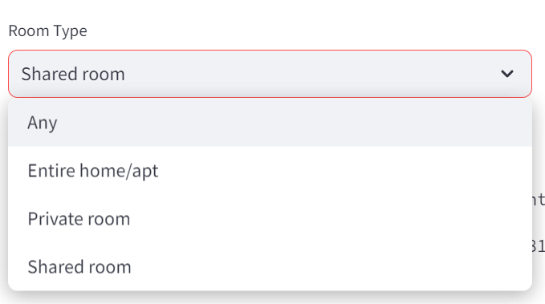

**Filter 4: Neighborhood**

The Neighborhood filter zooms in on specific suburbs, offering a detailed view of data for a chosen location. A dropdown menu allows you to select the desired suburb, refining your analysis to Airbnb listings in that particular area. This filter is perfect for users interested in exploring data for specific neighborhoods, enabling a localized and nuanced understanding of the Airbnb landscape.

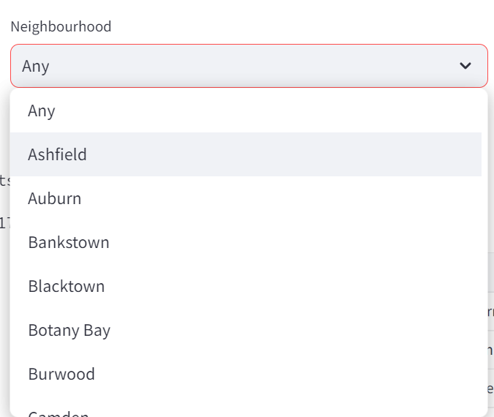

**Filter 5: Chart Type**

The Chart Type filter offers three distinct visualization options:

* **Room Type Chart:**
  + Gain insights into data categorized by room type.
* **Suburbs Chart:**
  + Obtain a geographical view of data, showcasing listings based on different suburbs.
* **Night Stays Chart:**
  + Illustrate data according to the duration of night stays.

Select the chart type that aligns with your analytical goals. Whether you're interested in room types, suburbs, or night stays, this filter ensures that the dashboard adapts to your preferred visual representation, enhancing your ability to derive meaningful insights.

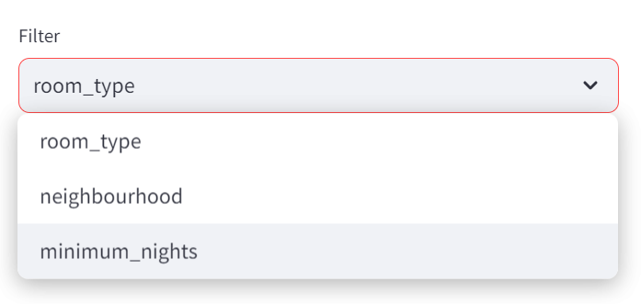

**Usage Tips:**

* Experiment with different combinations of filters to gain a comprehensive understanding of the Airbnb data.

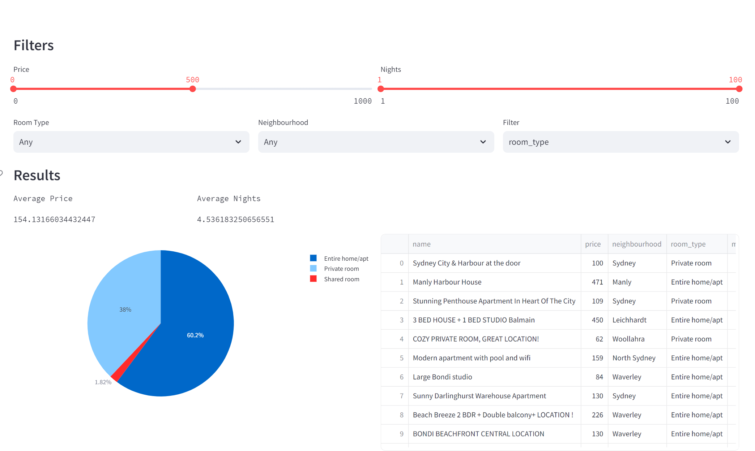

**Conclusion:**

In conclusion, our Dashboard is a versatile and powerful tool designed to cater to your analytical needs. The five filters—Price Range, Minimum Stays Range, Room Type, Neighborhood, and Chart Type—provide a customizable and personalized experience, allowing you to extract valuable insights from the diverse world of Airbnb listings. Enjoy exploring and making informed decisions with our intuitive and feature-rich Dashboard!